WT Assignment 7
Neeti Kurulkar
Web App using PHP and MySQL

Create Database and Table in XAMPP
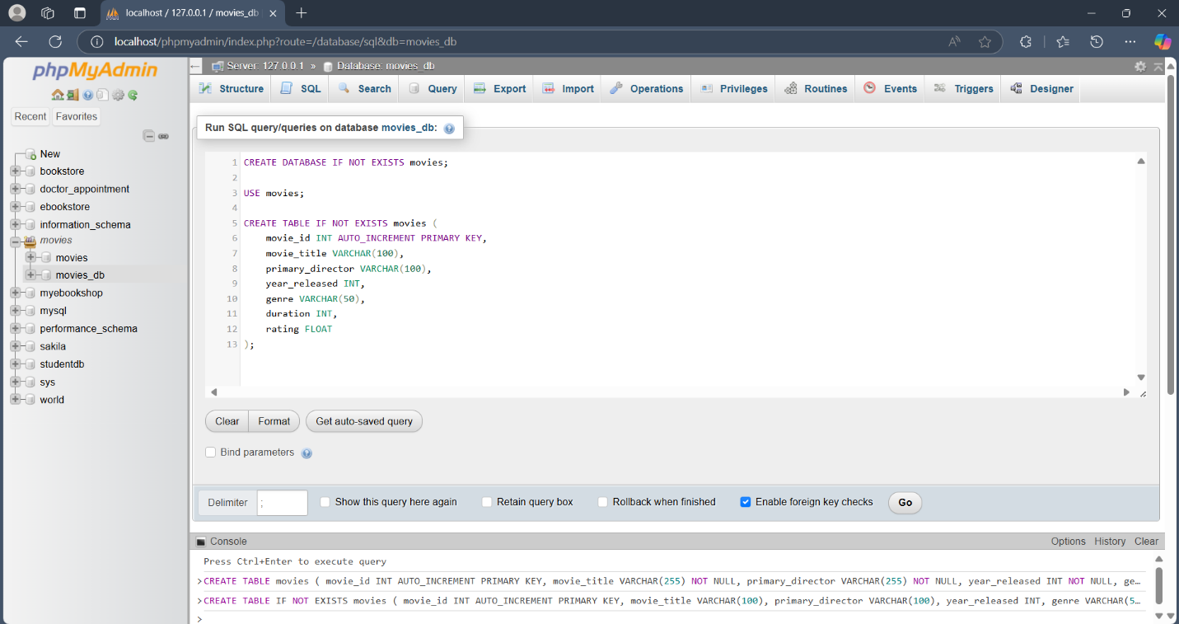
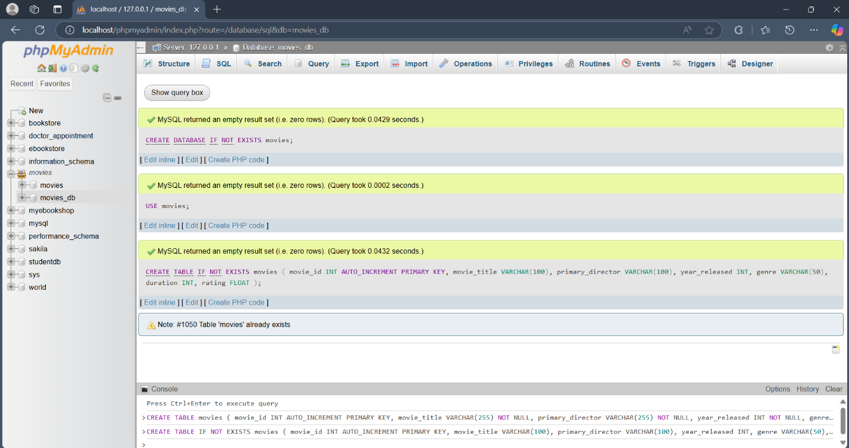

PHP Codes

- Db_connect.php

<?php
$servername = "localhost";
$username = "root";
$password = "Neeti_0107";
$dbname = "movies";

$conn = new mysqli($servername, $username, $password, $dbname);

// Check connection
if ($conn->connect_error) {
die("Connection failed: " . $conn->connect_error);
}
?>

- Index.php

<?php include 'db_connect.php'; ?>
<!DOCTYPE html>
<html>
<head>
<title>Movies Dashboard</title>
<style>
body {
font-family: 'Segoe UI', sans-serif;
background: #f4f4f4;
padding: 30px;
}
.container {
max-width: 900px;
margin: auto;
background: white;
padding: 20px;
border-radius: 10px;
box-shadow: 0 4px 12px rgba(0,0,0,0.1);
}
h2 {
text-align: center;
}
a.btn {
padding: 8px 12px;
margin: 5px;
border-radius: 5px;
text-decoration: none;
color: white;
font-weight: bold;
}
.btn-add { background: #28a745; }
.btn-update { background: #ffc107; color: black; }
.btn-delete { background: #dc3545; }
table {
width: 100%;
border-collapse: collapse;
margin-top: 20px;
}
th, td {
padding: 10px;
border-bottom: 1px solid #ddd;
}
th {
background: #007bff;
color: white;
}
tr:hover {
background: #f1f1f1;
}
</style>
</head>
<body>
<div class="container">
<h2>🎬 Movies Dashboard</h2>
<a href="add_movie.php" class="btn btn-add">➕ Add New Movie</a>
<table>
<tr>
<th>Title</th>
<th>Director</th>
<th>Year</th>
<th>Genre</th>
<th>Duration</th>
<th>Rating</th>
<th>Actions</th>
</tr>
<?php
$result = $conn->query("SELECT * FROM movies");

if (!$result) {
die("Query failed: " . $conn->error);
}
while ($row = $result->fetch_assoc()) {
echo "<tr>
<td>{$row['movie_title']}</td>
<td>{$row['primary_director']}</td>
<td>{$row['year_released']}</td>
<td>{$row['genre']}</td>
<td>{$row['duration']} min</td>
<td>{$row['rating']}</td>
<td>
<a href='update_movie.php?id={$row['movie_id']}' class='btn btn-update'>Update</a>
<a href='delete_movie.php?id={$row['movie_id']}' class='btn btn-delete' onclick='return confirm(\"Are you sure?\")'>Delete</a>
</td>
</tr>";
}
?>
</table>
</div>
</body>
</html>

- Add_movie.php

<?php include 'db_connect.php';

if (isset($_POST['submit'])) {
$title = $_POST['movie_title'];
$director = $_POST['primary_director'];
$year = $_POST['year_released'];
$genre = $_POST['genre'];
$duration = $_POST['duration'];
$rating = $_POST['rating'];

$conn->query("INSERT INTO movies (movie_title, primary_director, year_released, genre, duration, rating)
VALUES ('$title', '$director', '$year', '$genre', '$duration', '$rating')");

header("Location: index.php");
}
?>

<!DOCTYPE html>
<html>
<head>
<title>Add Movie</title>
<style>
body {
font-family: sans-serif;
padding: 30px;
background: #f9f9f9;
}
.form-box {
max-width: 600px;
background: white;
padding: 20px;
margin: auto;
border-radius: 8px;
box-shadow: 0 4px 12px rgba(0,0,0,0.1);
}
input, button {
display: block;
width: 100%;
padding: 10px;
margin-top: 10px;
font-size: 16px;
}
button {
background: #28a745;
color: white;
border: none;
font-weight: bold;
}
</style>
</head>
<body>
<div class="form-box">
<h2>Add New Movie</h2>
<form method="POST">
<input type="text" name="movie_title" placeholder="Movie Title" required>
<input type="text" name="primary_director" placeholder="Primary Director" required>
<input type="number" name="year_released" placeholder="Year Released" required>
<input type="text" name="genre" placeholder="Genre" required>
<input type="number" name="duration" placeholder="Duration (in mins)" required>
<input type="number" step="0.1" name="rating" placeholder="Rating (0-10)" required>
<button type="submit" name="submit">➕ Add Movie</button>
</form>
</div>
</body>
</html>

- Update_movie.php

<?php include 'db_connect.php';

$id = $_GET['id'];
$result = $conn->query("SELECT * FROM movies WHERE movie_id = $id");
$row = $result->fetch_assoc();

if (isset($_POST['update'])) {
$title = $_POST['movie_title'];
$director = $_POST['primary_director'];
$year = $_POST['year_released'];
$genre = $_POST['genre'];
$duration = $_POST['duration'];
$rating = $_POST['rating'];

$conn->query("UPDATE movies SET
movie_title='$title',
primary_director='$director',
year_released='$year',
genre='$genre',
duration='$duration',
rating='$rating'
WHERE movie_id = $id");

header("Location: index.php");
}
?>

<!DOCTYPE html>
<html>
<head>
<title>Update Movie</title>
<style>
body { font-family: sans-serif; padding: 30px; background: #f0f0f0; }
.form-box {
max-width: 600px;
background: white;
padding: 20px;
margin: auto;
border-radius: 8px;
box-shadow: 0 4px 12px rgba(0,0,0,0.1);
}
input, button {
display: block;
width: 100%;
padding: 10px;
margin-top: 10px;
font-size: 16px;
}
button {
background: #ffc107;
color: black;
border: none;
font-weight: bold;
}
</style>
</head>
<body>
<div class="form-box">
<h2>Update Movie</h2>
<form method="POST">
<input type="text" name="movie_title" value="<?= $row['movie_title'] ?>" required>
<input type="text" name="primary_director" value="<?= $row['primary_director'] ?>" required>
<input type="number" name="year_released" value="<?= $row['year_released'] ?>" required>
<input type="text" name="genre" value="<?= $row['genre'] ?>" required>
<input type="number" name="duration" value="<?= $row['duration'] ?>" required>
<input type="number" step="0.1" name="rating" value="<?= $row['rating'] ?>" required>
<button type="submit" name="update">🔄 Update Movie</button>
</form>
</div>
</body>
</html>
- Delete_movie.php

<?php
include 'db_connect.php';

if (isset($_GET['id'])) {
$id = $_GET['id'];
$conn->query("DELETE FROM movies WHERE movie_id = $id");
}

header("Location: index.php");
?>

Output

